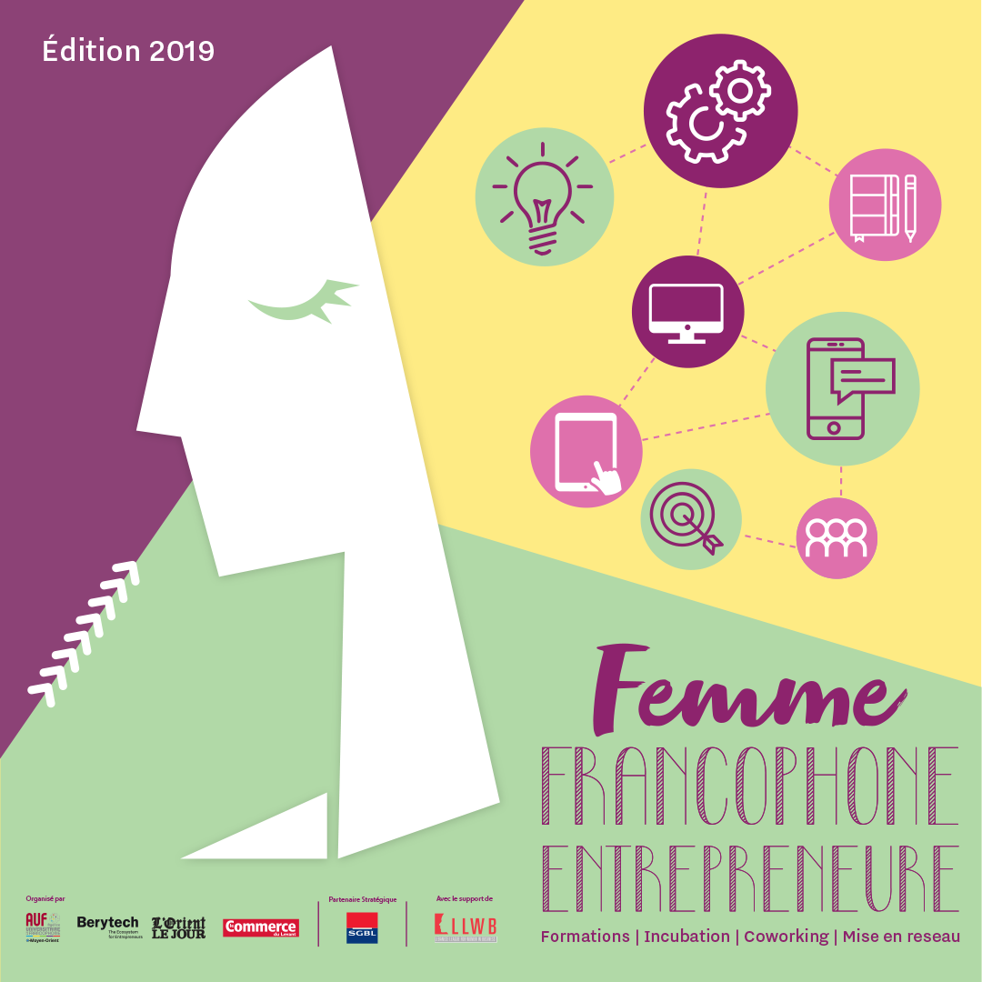

Press Release

Launching of the 8th Edition of the “Femme Francophone Entrepreneure” Competition

The 2019 edition of the “Femme Francophone Entrepreneure” (FFE) competition was launched under the patronage of Her Excellency Mrs. Violette Khairallah, Minister of State for the social and economic integration of the youth and women. This competition is organized by AUF Middle East and Berytech, in partnership with L'Orient-Le Jour and le Commerce du Levant. It enjoys the strategic partnership of SGBL and the community partnership of the LLWB. For the past 8 years, it has been promoting women’s entrepreneurship in Lebanon.
Every year, a €20,000 subsidy is granted to the most promising projects. Winners will receive the necessary accompaniment for the creation of companies, as well as support to a start-up at Berytech incubator. L’Orient-Le Jour and Le Commerce du Levant have partnered with the competition since 2016 for a maximum visibility.
This new edition will reward two enterprise creation projects. The call for applications was launched on May 15, 2019 on the partners’ websites and social media.
It is worth recalling that 90 applications were received in 2018, which shows the attractiveness of this pioneering francophone competition in Lebanon. Maya Bacha, co-founder of Sidelick, an innovative pet-sitting service, and Marielle Khayat, co-founder of Koullouna, a company which ships to expats and amateurs from Lebanon parcels containing products from their country of origin, won the 2018 edition and they currently benefit from the necessary accompaniment for the development of their company.

Calendar
The competition is organized in 4 stages:
- The 1st online application stage: Submission of an application pre-file. Deadline: june 20, 2019. The results, along with the names of the 25 applicants, will be announced on june 28, 2019.
- The training stage: 4 training days open to the 25 applicants who were shortlisted in july 2019: monday, july 1, 2019, monday, july 8, 2019, monday, july 15, 2019 and monday, july 22, 2019 from 4:00 pm to 6:00 pm at Berytech Mathaf, 10th floor.
- The 2nd online application stage: Submission of the complete file with a business plan before august 16, 2019. On august 30, 10 semi-finalists will be announced and will undergo an intensive training on their pitch. A committee of representatives from AUF Middle East, Berytech, l’Orient-Le Jour and le Commerce du Levant, as well as SGBL, will assess the pitches and select 5 finalists on september 17.
- Final pitch: The 5 finalists will pitch before the jury and the public on september 25, 2019. The two winners will be announced on the same day.
To apply: https://competitions.berytech.org/ffe/

For any additional information, kindly contact: support@berytech.org.

Press Contact:
Joëlle RIACHI
Communication officer
AUF Middle East
joelle.riachi@auf.org
Tel.: +961 1 420269

