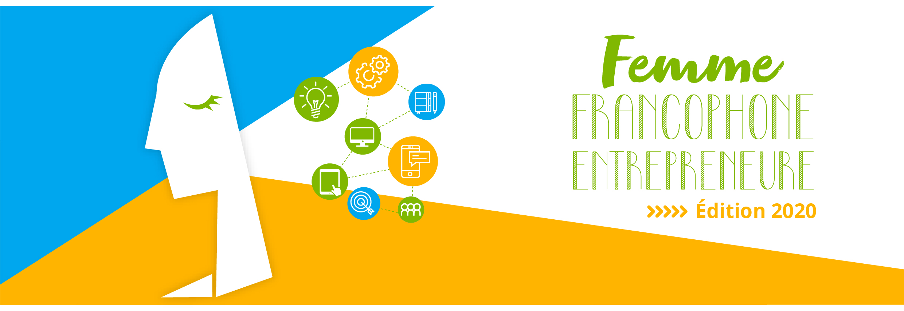

Press release

Launching of the 9th edition of the “Femme Francophone Entrepreneure” Competition

Beirut, May 15, 2020- Despite the current difficult situation and the measures taken in order to fight the COVID-19 pandemic, the 2020 edition of the «Femme Francophone Entrepreneure » (FFE) competition was launched today and efforts were made in order to adapt to the new health context. This competition is organized by AUF Middle East and Berytech, in partnership with L'Orient-Le Jour and le Commerce du Levant, and it has been promoting women’s entrepreneurship in Lebanon for the past 9 years. Partners continue to believe in the potential of startups which are conducting their investments despite the difficulties inherent to the Lebanese ecosystem which is plagued by two simultaneous crises: an economic and a health one. “Femme Francophone Entrepreneure” is there to help them and contribute to their resilience.
This edition inaugurates a new competition concept which includes 3 categories this year, i.e. research, technological innovation and social entrepreneurship, and will, therefore, reward three projects on enterprise creation. The call for applications is now available on the partners’ institutional websites and social media pages.
A €20,000 grant will be given by AUF and split among the winning projects. This year’s three winners will thus benefit from the necessary accompaniment to create an enterprise, as well as from the needed support to a start-up in Berytech incubator.
The research part is a novelty. It was added in order to enable women to give value to their research project and turn it into a flourishing enterprise. Indeed, one of the main challenges that research laboratories are currently facing consists in moving from discovery to implementation or marketing.
It is worth recalling that sixty applications were received last year. This shows the attractiveness of the competition which pays tribute to francophone women’s commitment to the innovation and enterprise creation challenge. Rosabelle Chedid and Rayanne Beayno were crowned « Femmes francophones entrepreneures 2020 » during the final of the competition in September last year.

Timetable
The competition will take place as follows:
- Deadline for the submission of applications: June 10, 2020
- Announcement of the chosen applicant for the 3 categories: June 17, 2020
- Online training: June 22 -29
- Submission of the Business Plan/Pitch: July 15, 2020
- Selection of the 9 finalists (3 per category): July 22
- Training and preparation for the pitch: last week of July
- Final in August

The application file should be written in French. Project presentations to the jury shall be made in French as well.
To submit your application, kindly go to: https://competitions.berytech.org/ffe/

For any additional information, kindly contact : support@berytech.org

Press Contact:
Joëlle Riachi
Communication Officer
AUF Middle East
joelle.riachi@auf.org
Phone: +961 3 780928

