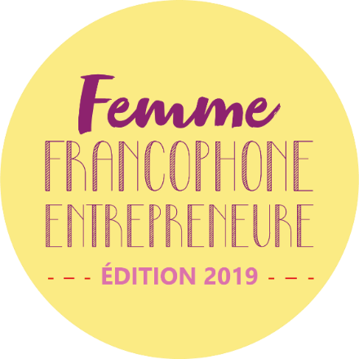

- Press Release –

Two winners of the 2019 edition “Femme Francophone Entrepreneure competition:
Quality of projects that meets the needs of the ecosystem

Beirut, Thursday, September 26, 2019 – The winners of the “Femme Francophone Entrepreneure competition” Rosabelle Chedid and Rayanne Beayno were named last night during the final of the competition, that aims since 2011 to support and promote women entrepreneurship.
Held under the patronage of Mrs. Violette Khairallah, Minister of State for the social and economic integration of the youth and women, the Agence universitaire de la Francophonie, Berytech, L’Orient-Le Jour, Commerce du Levant and SGBL organized the final ceremony of the FFE competition at François Bassil Amphitheater, campus of Innovation and Sport of Saint Joseph University of Beirut (USJ).

Around 60 applications were received this year, which shows the attractiveness of this pioneering competition and celebrates the commitment of Francophone women in favor of innovation and entrepreneurship.

5 candidates, representing as many teams, competed in the final of this competition:
- Rayanne Beayno – Mushtic (a biodegradable alternative for polystyrene, which has the same characteristics as polystyrene with regard to impact resistance and tolerance to water and heat, while being environmentally-friendly).
- Rosabelle Chedid – C Green (a startup that treats one of the most hazardous waste for our environment in Lebanon, which is sludge that is currently being dumped into water and soil randomly).
- Rouba Khoury – Pragma (fintech software offering innovative solutions, with great flexibility, allowing the computerization of processes and conditional workflows for client companies in order to reduce their operating time).
- Marie-Elizabeth Ragi – VITALIP (lipstick that provides women with their recommended daily intake for vitamins B9, B12 and D).
- Elise Sfeir – Fill’nForm (platform that fills, records and manages any formality automatically in one click).

They each had 5 minutes to pitch and try to convince the jury and the public of the validity of their startups.
After the pitches, the two winners were nominated by the jury composed this year of Christine Francis (coach and mentor -VIVITI), Zakie Karam (co-founder and director- DON Telecom), Stéphanie Hanna (founder of Essmak and winner of FFE in 2015) and the partners representative Constantin Salameh (investment consultant Berytech).

The grant awarded estimated at 20,000 euro, as each winner is receiving 10.000 euros will be paid directly to Berytech to cover the costs related to the integration of project leaders and their teams in incubation and provide them with appropriate support for the creation of their companies.

Special guest speakers Mrs Emilie Sueur, editor-in-chief of L'Orient-Le Jour and Mrs Lise Yacoub, co-founder of M.A.D. - Music.Arts.Design, addressed the challenges of women's entrepreneurship in general, and shared their experience as a women entrepreneur.

Mr. Hervé Sabourin, regional director of AUF in the Middle East underlined in his word of welcome that « more than ever, this event, in its 8th edition, symbolizes and celebrates the commitment of women in the Middle East in favor of innovation and entrepreneurship, the commitment of francophone women and even more of Lebanese francophone women, as shown by the quality of the projects submitted and their capacities to meet the needs of the local ecosystem».

For her part, Joanna Baloglou, head of corporate communication at SGBL (strategic partner), said that « SGBL supports, on a daily basis, entrepreneurs in their startups and projects. The Woman Francophone Entrepreneur competition, that is part of this approach, is a key element for us since these projects are initiated exclusively by women; this allows us, as a bank committed to promoting diversity, to support women to create, innovate and contribute to the economic development of the country ».

As for Michel Helou, executive director of L’Orient-Le Jour, he said that « it is a real breath of fresh air to see these women tell us their stories, theirs projects and their ambitions. Lebanese women should be considered as an example for the whole region that is in difficulty and even beyond. And if it can be in French it is even better».
The representative of the rector of the USJ Mrs. Dolla Sarkis commented that «Women in Lebanon still suffer from gender inequity and visibility in many areas and in particular in the world of business».
For his part, Mr Maroun Chammas Berytech Chairman and CEO said that « we are proud to be partners of this competition as we play an active role in the implementation of it. This edition is introducing us to the 4th industrial revolution thanks to our finalists who today innovate in cleantech, fintech, in logistics and in health ».

The Minister Safadi concluded that « this competition fits naturally in the way I understand my role and the mission entrusted to me. But I must say that I execute it, in this case, with great enthusiasm, as I am convinced that the involvement of women in the Business world and in particular in entrepreneurship marks a clear evolution in equality of rights between men and women, while giving a new impetus to the country's economy ".

Press Contacts:

AUF Moyen-Orient  Joëlle RIACHI  Head of communications and Outreach  +961 1 420 270  joelle.riachi@auf.org | Berytech  Reina DIB ANGOUJARD  Head of communications and Outreach  +961 1 612 500  reina.dib@berytech.org | L'Orient-Le Jour  Hanaa GEMAYEL JABBOUR Marketing Manager  +961 3 192 302  hanaajabbour@lorientlejour.com | SGBL  Christelle Feghaly  Responsable Relations Médias  +961 1 499 813  christelle.feghaly@socgen.com

