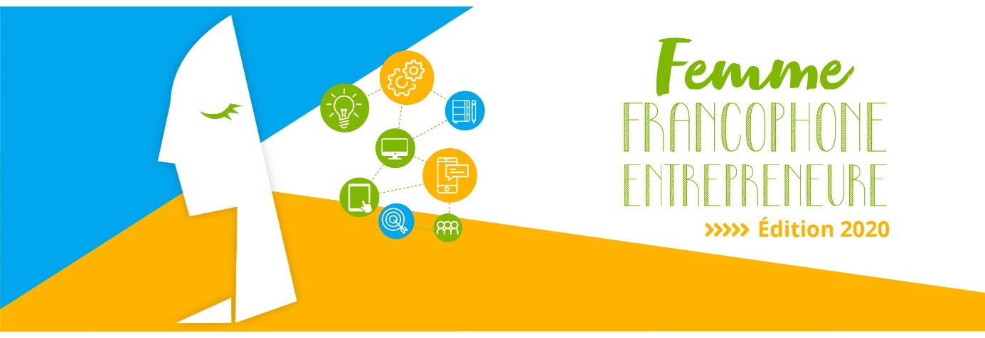

Press Release

“Femme Francophone Entrepreneure 2020” is contributing to the resilience of Lebanese women: 3 winners and a great deal of innovation!

Beirut, September 30, 2020- The economic crisis which has been plaguing the country for the past months and which was aggravated by the COVID 19 pandemic and the August 4 blast could not get the better of the Lebanese women spirit of resilience. Indeed, 3 women (Sandra Berro, Gaëlle Fayad and Lina Al Khoury) won yesterday the 2020 final of the “Femme Francophone Entrepreneure” (FFE) contest which took place in Berytech, Mar Roukoz, in a very reduced format.
This contest, which is organized by AUF Middle East and Berytech, in partnership with L'Orient-Le Jour and le Commerce du Levant, has been promoting women entrepreneurship in Lebanon for the past 9 years. Partners still believe in the potential of startups which are pursuing their investments despite the difficulties that are inherent to the Lebanese ecosystem with the management of two concurrent crises : “Femme Francophone Entrepreneure” is always there to help them and contribute to their resilience.
The call for applications was launched in June 2020. 90 files were received (30 of which were selected and referred for various types of training), which shows the attractiveness of this competition that pays tribute to the commitment of francophone women to the innovation and enterprise creation challenge. The submitted projects were assessed in the light of criteria based on innovation, market study, viability and complementarity of the team members’ competencies.
8 candidates, representing 8 teams, confronted each other during the final:
- Sandra Berro - Arabizon (cultural products and toys for children)
- Gaëlle Fayad - Scriptofilm (an online market which connects scriptwriters and film directors to producers, investors and buyers)
- Lina Al‐Khouri - Counsela (an anonymous and affordable online psychological counseling platform which aims at enabling individuals to better control their emotional health)
- Alexandra Kodjabachi - PersEd Connect (a platform linking the country’s young talents to online training opportunities, as well as to a mutual support and coaching community)
- Malak Bazzi - The Red Bee (a bracelet which detects intimidation, “Bullying”, in Lebanese schools)
- Stephanie Bassil - Spree Vr (an application which broadcasts events live at 360 degrees where fans can experience full immersion using their VR headset)
- Sandy Rihana - Teleppocrate (professional medical follow-up through the development of care and educational services backed by medical technologies)
- Nancy Nasr - Bacteria Protection (limiting, through innovative ideas, the dissemination of airborne and cutaneous microorganisms)
The participants had 5 minutes each to make their “pitch” before the jury and try to convince them of the relevance of their projects.
Following this presentation, the three winners were designated by the jury which included this year Jihad Bitar (director of Smart ESA), Lara Macaron (affairs consultant and assistant professor of finance) and Patricia Kebbé (consultant in corporate marketing development, coach and mentor).
A €20,000 grant will be given by AUF and split among the winning projects. This year’s three winners will thus benefit from the necessary accompaniment to create an enterprise, as well as from the needed support to a start-up in Berytech incubator.
Mr. Jean-Noël Baléo, regional director of AUF Middle East, declared in his opening speech: “Given the current circumstances in Lebanon, this contest takes on a special symbolic meaning this year. First, its success, with nearly 90 participants despite the pandemic, despite the successive crises and despite adversity, constitutes a form of resistance to despondency. Last and above all, the francophone women entrepreneurs are showing us today, with flying colors, a conjunction of solutions and talents which the country is in dire need of and which fall under the headlines of creativity, expertise, energy, determination and faith in the future. This bears witness to the fact that, more often than not, feminization is the right solution.”

The Chairman and CEO of Berytech, Mr. Maroun Chammas asserted: “This year has been undeniably difficult for all of us, men and women. However, the finalists of the current edition of the FFE competition were ready to pitch their innovative and creative ideas before the members of the jury, thanks to the sound advice and to the intensive trainings they have received since the beginning of summer. We support and encourage these 8 Lebanese startups which are led by ambitious, exceptional and talented women because we are very proud of them.”

Mr. Michel Helou, the executive director of L’Orient-Le Jour, declared: “Our women entrepreneurs are responding to daily life problems through well-thought-out and innovative solutions. As a matter of fact, this is what makes a good entrepreneur, i.e. the capacity to seek inspiration in everyday needs to create a concept, breathe life into it and then market it.”

Press contact:
Joëlle Riachi
Communication officer
AUF Middle East
joelle.riachi@auf.org
Phone: +961 3 780928

