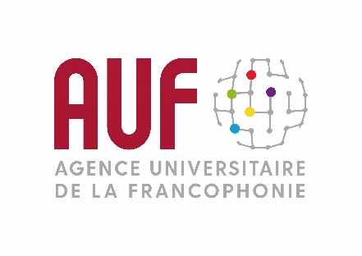

THE MONTH OF THE FRANCOPHONIE:
AUF MIDDLE EAST 2020 PROGRAM

Every year, in March, Lebanon celebrates the Month of the Francophonie. This event, which is organized under the auspices of the Ministry of Culture, with the partnership of the Agence universitaire de la Francophonie (AUF) and the embassies of French-speaking countries, is a major highlight of Lebanon cultural life.

Writing workshops on “The Walls” topic
March 4 – 13, 2020

“But there will always be walls that encircle, separate, alienate, protect and don’t heal the hearts”.
The regional office of the Agence universitaire de la Francophonie in the Middle East is organizing writing workshops run by novelist Salma Kojok in partnership with the French Institute in Lebanon. This year’s topic, “The Walls”, is inspired by the work of Nathacha Appanah “Le ciel par-dessus le toit” (the sky above the roof), winner of the 2019 edition of the Choix Goncourt de l’Orient.
The universities participating in this workshop are: The Lebanese University through its 5 branches, Saint Joseph University, Jinan University, Balamand University, Holy Spirit University of Kaslik and the Islamic University of Lebanon.

The Francophone Digital Campus in Tripoli celebrates its 10th anniversary
March 20, 2020

On the occasion of the tenth anniversary of the Francophone Digital Campus (CNF) in Tripoli, AUF is organizing a gathering on March 20 at 3:00 pm at the Mont Michel Campus in Tripoli in order to celebrate AUF presence in Tripoli which is at the service of all of the institutions falling under its geographical area in North Lebanon. The CNF is both a place that welcomes and trains researchers and students by putting at their disposal a number of training and research means and tools through information technologies.

International Eloquence Debate Championship
March 23 – 26, 2020

The Division of Student Life at Saint Joseph University in Beirut is organizing the 5th edition of the international debate championship in French and Arabic, in partnership with the Agence Universitaire de la Francophonie in the Middle East.
As has been the case in the previous years, debaters from different nationalities will meet to discuss some of the controversial topics that are making the news in order to show their eloquence and their capacity to submit arguments.
The 2020 edition will be held from March 23 to 26 at USJ. The final will take place on March 26 at 6:00 pm.

“The Francophonie Golden Word”
March 27, 2020

AUF Middle East office, the association “Actions to promote business French” (APFA), the French Institute in Lebanon and the Institut des Finances Basil Fuleihan are organizing the Lebanese edition of “The Francophonie Golden Word”. This contest, which aims at promoting the use of French as a business language, targets two categories: students under 27 and young professionals under 40. The final will take place on March 27, at the Antonine University.

A concert paying tribute to Charles Aznavour
March 28, 2020

Within the scope of Armenia’s presidency of the Francophonie Summit and under the aegis of the group of French-speaking ambassadors, the Agence Universitaire de la Francophonie and the Armenian General Benevolent Union are organizing a concert paying homage to Charles Aznavour performed by Yvonne el Hachem, on Saturday, March 28 at 8:00 pm, at AGBU Center in Dbayeh.

For more information:
www.auf.org/moyen-orient
https://twitter.com/AUF_MoyenOrient
https://www.facebook.com/AUF.MoyenOrient/

