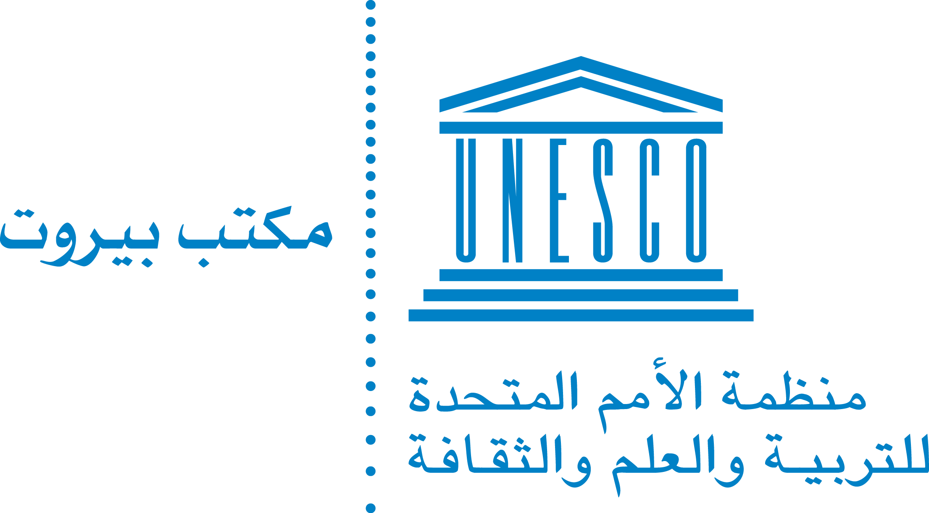

Digital Transformation and Open Education Resources (OER):
Toward quality and recognition at the Syrian Universities

Program:

8.5.2018 Participants arrival to Beirut

First Day: 9.5.2018

9:00-10:00 Opening
Presentation of the Agenda and selection of the rapporteur
10:00-10:30 Key Note speech / UNESCO BO
10:30-11:00 Break
11:00-11:45 Tunisian Virtual University, Rector, Dr Jilani Lamloumi
11:45-12:20 Impact of digital transformation on higher education institutions and challenges of open education resources, Dr Pierre Gedeon, Lebanese Canadian university
12:20-13:00 Discussions
13:00-14:00 Lunch
14:00-16:00 Higher Education and Universities during the Syrian crisis
16:00-16:30 Summary

Second day: 10.5.2018

9:00-10:00 Digital transformation in Lebanese Universities
- OER and pedagogical challenges – Dr Hisham Al Khoury
- OER: Quality and recognition – Dr Rima Malek
10:00-11:30 Working groups
- Group 1: OER/Content/Technology – Dr Jilani Lamloumi
- Group 2: OER/Quality/Recognition – Dr Rima Malek
- Group 3: OER/Pedagogical challenges – Dr Hisham Al Khoury
11:30-12:00 Break
12:00-13:00 Presentations of the working groups and discussions
13:00-13:30 Summary and way forward
13:30-14:30 Lunch

